Events in Spring 2018

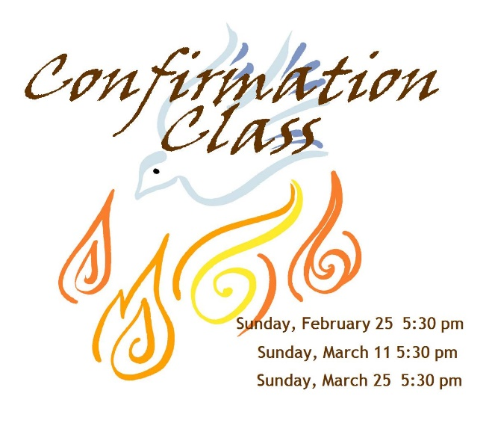

April 15: Studying and Knowing the Bible
April 29: What is this thing call “Presbyterian”?
May 13: Session Examination
May 20: Join the church!
April 1: Men of the Church
April 8: Young Adult Sunday School
April 15: Youth
April 22: MVE Committee
April 29: Scouts or Young Adult Sunday School
May 6: Men of the Church
May 13: Young Adult Sunday School
May 20: Youth
May 27: MVE Committee





Wednesday, April 25, 2018 6:00 pm
Elders in Charge: Coke Gray III and Brent Wheatley
Wednesday, May 23, 2018 6:00 pm
Elders in Charge: Ben Kilpatrick and Fuller Royal

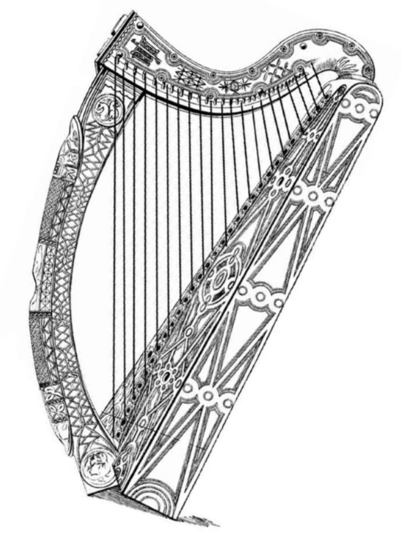
Offering Collected:
April 27 May 27




The church office will be closed for
Memorial Day, May 28, 2018
Sunday, May 20, 2018
Southeastern Oratorio Society Spring Concert
Monday, May 7, 2018

