Gathering Around the Word
First
Presbyterian
Church
Whiteville,
North Carolina
“To be a light in our community reflecting Christ’s love and compassion…”

Second Sunday of Lent
February 28, 2021

Rev. Dr. Joseph D. Washburn

Welcome

Prelude

Announcements

Call to Worship
Come to this space and time of repentance.
We gather as a people of God.
Come to this time and space of renewal.
We gather as a people of Christ.
Come to this space and time of grace.
We gather as a people of the Spirit. We live
as a people of hope.

Opening Prayer

Hymn of Praise
“Blessed Assurance, Jesus Is Mine!”

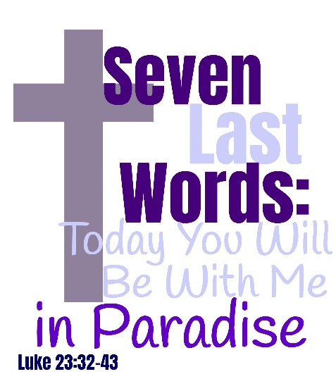
Call to Confession

Prayer of Confession
Merciful Savior, forgive us our sins. We
confess that we do not hold you close in our
daily lives. We confess that we separate our
decisions from your will. We confess that we
insist on paths of destruction rather than
paths of life. We confess that we prefer to be
admired rather than faithful. Forgive us we
pray. Realign our wills with your hopes for us.
Amen.

Assurance of Forgiveness
God’s hope for us is here for the knowing.
May we be blessed with grace and peace as a
forgiven people.

Proclaiming the Word
Children’s Sermon

Scripture Lesson Luke 23:32-43
³² Two others also, who were criminals, were led
away to be put to death with him. ³³ When they
came to the place that is called The Skull, they
crucified Jesus there with the criminals, one on his right and one on his left. ³⁴ Then Jesus
said, “Father, forgive them; for they do not know what they are doing.” And they cast lots
to divide his clothing. ³⁵ And the people stood by, watching; but the leaders scoffed at him,
saying, “He saved others; let him save himself if he is the Messiah of God, his chosen
one!”³⁶ The soldiers also mocked him, coming up and offering him sour wine, ³⁷ and saying,
“If you are the King of the Jews, save yourself!” ³⁸ There was also an inscription over him,
“This is the King of the Jews.” ³⁹ One of the criminals who were hanged there kept deriding
him and saying, “Are you not the Messiah? Save yourself and us!” ⁴⁰ But the other rebuked
him, saying, “Do you not fear God, since you are under the same sentence of condemnation?
⁴¹And we indeed have been condemned justly, for we are getting what we deserve for our
deeds, but this man has done nothing wrong.” ⁴² Then he said, “Jesus, remember me when
you come into your kingdom.” ⁴³ He replied, “Truly I tell you, today you will be with me in
Paradise.”
This is the Word of the Lord;
Thanks be to God!

Sermon Rev. Dr. Joseph D. Washburn
“Seven Last Words: Today You Will Be with Me in Paradise”

Hymn of Response “Lamb of God”

Responding to the Word
Affirmation of Faith Apostles’ Creed
I believe in God, the Father Almighty, Maker of heaven and earth, and in Jesus
Christ his only Son, our Lord; who was conceived by the Holy Ghost, born of the
Virgin Mary, suffered under Pontius Pilate, was crucified, dead, and buried; he
descended into hell; the third day he rose again from the dead; he ascended into
heaven, and sitteth on the right hand of God the Father Almighty; from thence he
shall come to judge the quick and the dead.
I believe in the Holy Ghost; the holy catholic church; the communion of saints; the
forgiveness of sins; the resurrection of the body; and the life everlasting. Amen.

Call to Stewardship

Prayers of the People and the Lord’s Prayer

Hymn of Commitment
“Softly and Tenderly Jesus Is Calling”

Charge and Benediction

Music in Preparation for Service in the World

Next Week:
Scripture: Mark 15:25-39
Sermon: “Seven Last Words: My God, My God”

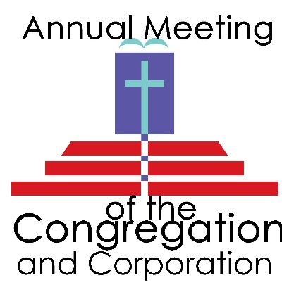
Presbyterian
Lenten Services 2021
511 North Thompson Street, Whiteville, NC 28472
Fpcwhiteville.org | 910-642-2253
Thursday, April 1:
Maundy Thursday 6:00 pm
First Presbyterian Church
Friday, April 2:
Good Friday 6:00pm
First Presbyterian Church
Sunday, February 28, 2021
We are starting a fundraiser to purchase an Omni All Body Active + Passive Trainer for Kenneth Smith that will provide him with daily exercise to create muscle mass, better blood circulation, and range of motion…all in one machine! This machine is used in many homes and rehab facilities all over the world for people that have had spinal cord injuries of some kind.
The total cost of this unit is $6,699.99 including shipping and handling. If you need any more information, please contact Pastor Joe or Karen at (910) 642-2253. If you would like to donate, you may do so by dropping it off at the church office, mailing it in (511 N. Thompson St; Whiteville, NC 28472), or by doing a one-time online donation. Checks should be made payable to “First Presbyterian Church” with “Kenneth Smith” in the memo line.
All donations are greatly appreciated!

After Worship

WELCOME! We welcome you in the name of our Lord and Savior Jesus Christ! May today’s worship open you to God.
Prayer Concerns: Geraldine Becker; John Hall; Bob High; Rita & R. L. Lewis; Walter Strickland.
Assisted Care: Anna Jane Collier; Charlene Hinnant; Kenneth Smith.
Friends: Pat Allen; Sarah Anglin; Michael Brown; Anne Burney; Ronnel Burney; Hugo & Paula Caesares; Matthew Coker; Billie Joe Conrad; Betty Engen Faircloth; Richard Hobgood; Shelby Hodge; Barry Housend; Phyllis Howlett; Martha & PW Jessup; Roger Kennedy; Julie Malone; Jerome McPherson; Carmen McQueen; Helen Reid; Shiryl Smith; William Smith; The Family of Emette and Sylvan Tedder; Nancy Washburn; Michael Ann Williamson.
Please notify the office when names can be removed.

- The flowers today are given to the glory of God in memory of Abbie Edwards from Rick Edwards.
- Congratulations to Pastor Joe and Angela Washburn on the birth of their grandson, George Alexander Suire.
Sound Team: February 28: Donald or Jenifer Hester March 7: Will Scott
Flowers: February 28: Rick Edwards March 7: _______________
Head Usher: February: Paul Pope March: Larry Thomas

CHURCH CALENDAR
Sunday, February 28: In-Person Worship Service – 11:00 am
(masks must be worn throughout worship)
Annual Meeting of the Congregation and Corporation, Sanctuary- 12:00 pm
Spiritual Development/Outreach Committee Meeting, Conference Room – 12:00 pm
Worship Committee Meeting, Parlor – 6:00 pm
Monday, March 1: Boy Scouts, Fellowship Hall – 6:30 pm
Alcoholics Anonymous, Community Room – 8:00 pm
Wednesday, March 3: Prayer Service, Zoom – 6:30 pm
Congregational Life Committee Meeting, Conference Room - 7:00 pm
Alcoholics Anonymous, Community Room – 8:00 pm
Thursday, March 4: Alcoholics Anonymous, Community Room – 8:00 pm
Alcoholics Anonymous, Community Room – 8:00 pm
Sunday, March 7: In-Person Worship Service – 11:00 am
(masks must be worn throughout worship)
Monday, March 8: Nuts and Bolts Committee Meeting, Conference Room – 6:30 pm
Boy Scouts, Fellowship Hall – 6:30 pm
Alcoholics Anonymous, Community Room – 8:00 pm
Wednesday, March 10: Prayer Service, Zoom – 6:30 pm
Alcoholics Anonymous, Community Room – 8:00 pm
Thursday, March 11: Alcoholics Anonymous, Community Room – 8:00 pm
Contact the church office: 910-642-2253 Website: www.fpcwhiteville.org
Pastor Joe: Cell: 910-625-8023 Email: pastorjoe@fpcwhiteville.org
NEW OFFICE HOURS: 8:30-2:30- Monday, Tuesday, Thursday, & Friday
Angela Washburn: joeandangelawashburn@gmail.com Karen: karen@fpcwhiteville.org
Live-Stream of Service: www.facebook.com/fpcwhiteville, Twitter, YouTube, Spectrum Channel 1304, and Roku

